”Follow me” controller

Course: Grundlæggende Indlejrede Systemer (GiS)
Modul 3, Regulering af dynamiske systemer
Group: Group N
Date:
Names: Anders Hvidgaard Poder
Henrik Arentoft Dammand

Introduction
Create a regulator that allows a car to follow another car at a predefined distance.

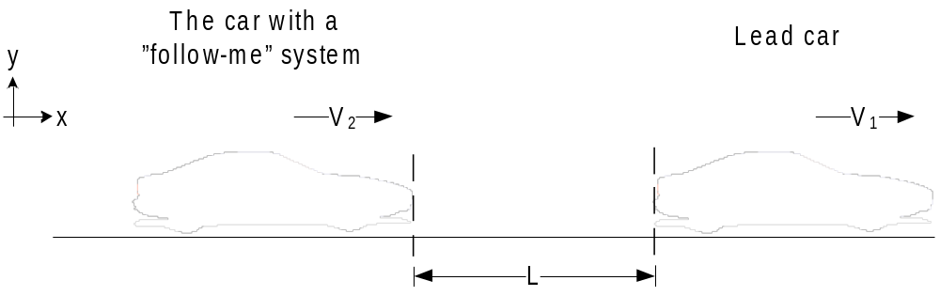
Figure 1, Overall view of the ‘follow me’ system
The ‘follow me’ system illustrated in Figure 1 consists of two vehicles. The front car leads the way while the rear car automatically follows the lead car at a fixed distance. The ‘follow me’ system continuously measure the distance to the lead car and automatically make adjustments to uphold the fixed distance. The ‘follow me’ system depicted in Figure 1 can be model as shown in Figure 2.

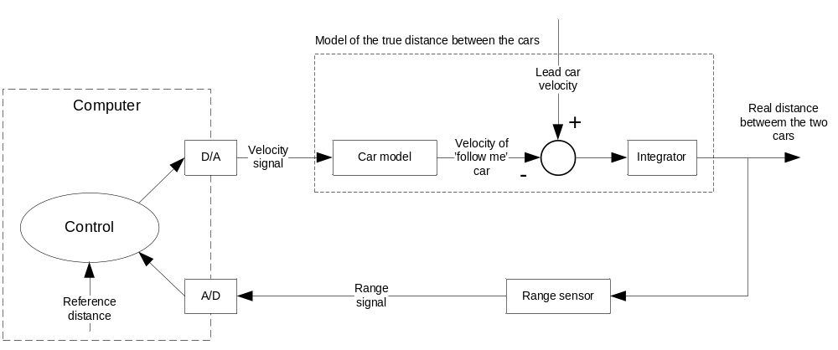
Figure 2, the overall regulator.
The computer block contains the control system can only make adjustment if it has a reference distance it compares with the measured distance and the difference is used to adjust the velocity.
The A/D converter and D/A converter in Figure 2 are seen as ideal with no delay and a perfect zero-order-hold and reconstruction filter (which is not practically possible). The same is true for the sensor which instantly returns the exact same value as the actual value. The ‘follow me’ controller is structured as it follows the principles of a basic feedback control system. Thereby, we can analyze and optimize feedback control system if we know each blocks transfer function.

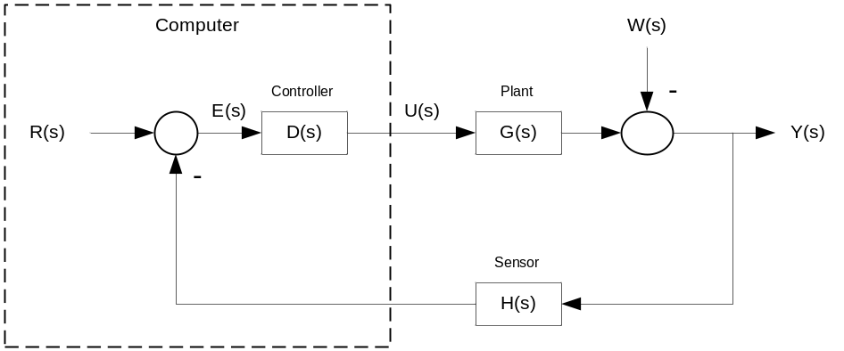
Figure 3, Basic feedback control system

Each block consists of a ‘Laplace’ transformed transfer function which is a mathematical model of the ‘follow me’ car, the relationship between the lead car and ‘follow me’ car, sensor and controller.

Model
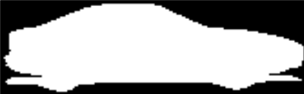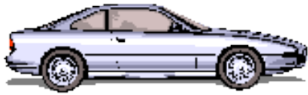
F
m
y
x
F
ad
F
g
F
rd
v
Frd
:
Force asserted on the car from rolling drag
.
Fad
:
Force asserted on the car from wind resistance
.
Fm
:
Force asserted on the car from the motor via the wheels
Fg
:
Gravitational force
v
:
velosity of vehicle due to the sum of all forces not being
0
.
Figure 4, Free body diagram of the ‘follow me’ vehicle

In the free body diagram above is only shown the overall forces affecting the system. Many, many has been ignored because they are negligible. A complete list will not be supplied, as it is almost always possible to come up with some that has not been considered. To give a few examples may be mentioned

- The capacitance generated between the windings in the endian – considered to have a negligible effect compared to the inductance and resistance.
- The initial friction resistance, which is non-linear and lager than the friction resistance lim car velocity -> 0.
- The temperature dependency of the tires spring effect.
- The loss in the transfer of torque from the engine shaft to the wheels.
- And so on and so on.

And this does not even include the assumptions made in the assignment (ignoring hills and changes in the wind, which would make the wind resistance non-linear).

Finally, since there is no changes in the road (no hills, no bumps) and we ignore the breaking and acceleration effect on the suspension (since the car has no breaks, we can simply assume that it has four-wheel-drive, and then the acceleration and breaking should be evenly distributed), we can ignore the effect of the tires and suspension, making the model much simpler.

Having no bumps, hills or turns (centrifical force is relative to mass and speed), and considering the tires ideal, the gravity force, being directly proportional to the other forces, irrelevant. This means that Fg can be ignored.

The contribution from the rolling drag (F_{rd}) can be calculated by

eq. 1

C_{rr} is the dimensionless rolling resistance coefficient. On a smooth road and low-resistance car tires the C_{rr} coefficient is low. In order to further simplify the model we assess the contribution from rolling drag to be negligible; hence we can eliminate F_{rd}.

This leave air drag F_{ad}, which act as an opposite force to the vehicle’s moving direction and is propotional to the velocity of the vehicle. For a matter of simplicity we make the air drag linear proportional to the velocity.

eq. 2

Where b is the air drag constant. The air drag equation is appropriate at relative slow speed (I.e. low Reynolds number, R_{e} < 1). However, we assume the air drag equation is valid for all speeds.

Using Newton’s second law that states that the net force applied to the vehicle produces a proportional acceleration we have:

eq. 3

Where F is the total force asserted on the mass (with sign and direction) so the equations can be collected to:
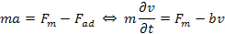 eq. 4

The force F_{m} is the net force from the vehicle’s wheels

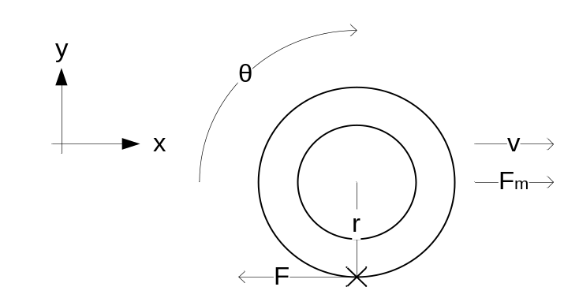

From the free body picture of a wheel we can establish an equation that gives the net torque applied to the wheel. The force F is equal with F_{m} with opposite sign i.e. F_{m} = -F.

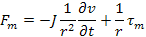 eq. 5

We combine eq. 4 with eq. 5 and we have:

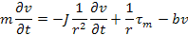 eq. 6

The torque t_{m} in eq. 6 is the contribution from the vehicle’s DC motor. A simplified model of a DC motor is shown below

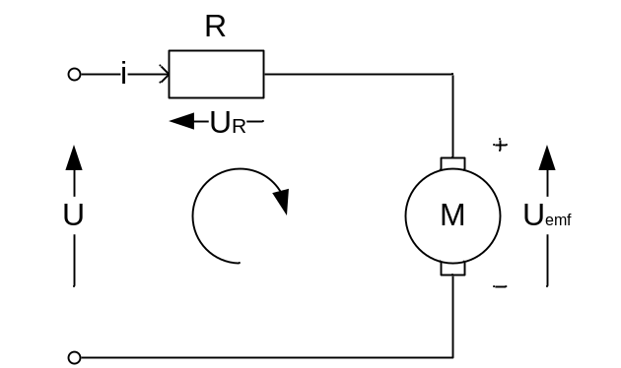

The DC motor’s torque is a linear proportional to the current and is motor torque constant and we have:

eq. 7

We can derive eq. 7 into angular momentum and we have:

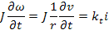 eq. 8

The DC motor’s angular velocity is defined as a linear voltage difference, proportional to the angular velocity of the armature shaft and and we have:

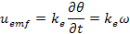 eq. 9

By using Kirchoff’s laws the following equation can be derived

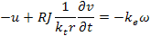

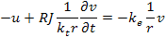

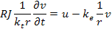

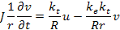 eq. 10

Hence, we can in eq. 10 substitute with torque and we have:

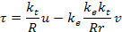 eq. 11

In eq. 11 the torque from the DC motor has been found and can be inserted into eq. 6 and we have:

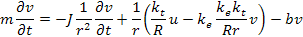

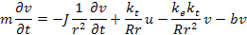
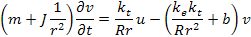 eq. 12

Equation 11 is reduced to interacting forces as a change of velocity over time and voltage. For simplicity we replace all the constants in reduced form:

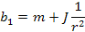

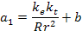

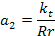

The parameters are explained below:
Mass of the vehicle
The net angular inertia of the vehicle
Radius of the wheel
Electrical resistance in the motor
Angular velocity constant
Torque constant
Wind resistance coefficient

We can rewrite equation 12 in reduced form and we have:

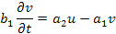 eq. 13

Equation 13 in Laplace transformed version we have:

eq. 14

The equation 14 can be rewritten and we find the vehicle’s transfer function

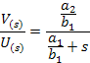 eq. 15

We substitute the constants and we have:

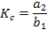 eq. 16

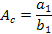 eq. 17

We can reduce equation 15

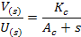 eq. 18

Simulation
In chapter 2 we were able to make a very simple mathematic model of ‘follow me’ car and describe the model in S-plan. Before we can use the model we need to realise some constants we can insert into the model. We have tried to pick some real data from a DC-motor and a medium car.

Mass of the car m = 1250 Kg
Wheel radius r = 0.325 m
Angular inertia J = J_{wheel} + J_{car} = 72kg * (0.325m)² / 2 + 1250kg * (0.325m)² = 136Kgm²

We don’t have a clue about the air drag coefficient b, but we guess the coefficient is relative small so we have made an assumption that the air drag coefficient b is equal to C_{w}, which is a dimensionless coefficient for relative large velocity.

Air drag coefficient b = 0.36

Now, we need to pick some real constants for the DC-motor and we have found some we think are sensible.

DC-motor resistance R = 0.118 ohm
Torque coefficient K_{t} = 5.9 Nm/A
U_{emf} coefficient K_{e} = 5.9 V/RPM

We can calculate K_{c} and A_{c} coefficients for the transfer function and we have

A_{c} = 1.1
K_{c} = 0.06068

We can hereby insert the coefficients into the eq. 18 and we have

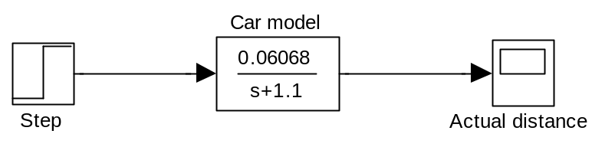
Figure 5, the car model in s-plan with coefficients

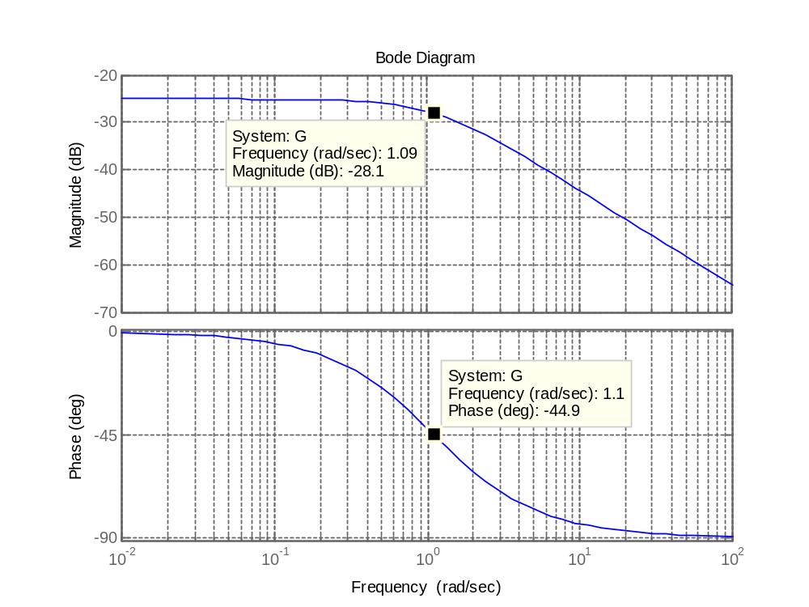
Figure 6, bode-plot of car model

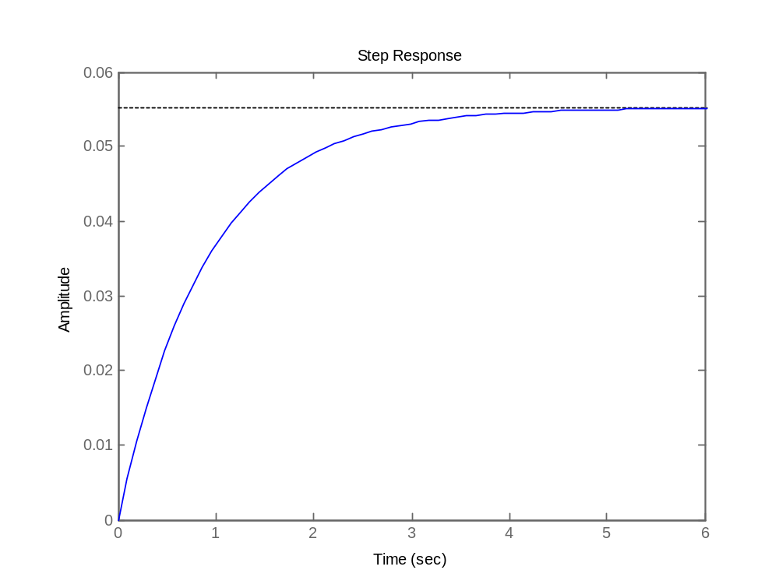
Figure 7, step response of the car model

Designing the regulator
We need to choose a regulator that can meet our requirements. Ideally we want to keep the distance perfectly, but that is theoretically impossible, even with perfect acceleration.

Even if we figure that there are no delay between the actual distance of the lead car and the regulator (this can be made small with a good sensor and fast sampling with good accuracy). And even if we choose a first order system with no delay (only dependent on the measured distance, not on the change) and have a perfect theoretical DAC. Then it is not possible to follow the lead car perfectly because the acceleration of the following car cannot be infinite, which would be required. We can however realise that it is a requirement that the maximum acceleration of the lead car must be smaller than the minimum acceleration of the follow-me vehicle.

This will allow us to catch up to the lead vehicle no matter how fast it accelerates (both negative and positive (breaking - so we also need better breaks)).

Assuming this is true then our job is to reduce the response time of the regulator as much as possible. Unfortunately this comes at a cost. If we want to quickly react to changes in the other cars velocity (and thereby its distance to us), we must quickly accelerate to catch up, and then, when we have caught up, decelerate, so we can keep the right distance. This is naturally possible, but would not make for very pleasant driving, as we would either be accelerating as much as possible or decelerating as much as possible - if you have ever tried to drive with an inexperienced driver who is afraid of the speeder, or one who mixes up the speeder and break, you know how that feels.

Another matter is one of safety. If we are to follow at 3 meter distance, then it is not good if we overshoot this distance by e.g. 4 meters, as this means we have hit the lead vehicle. Based on this we can set a requirement that we must never have an overshoot of more than the reference distance (1).

To make this more specific an overshoot of 30% (leaving some for inaccuracies in the model, coefficients and sampling) would be a good maximum value.

Requirement 1: Maximum overshoots 30%

Another important aspect is stability. Stability of a first order system can be directly seen on a bode plot, where it is important that we have a phase-margin above 0 (i.e. less than -180 degrees). A good rule of thumb is to keep a phase-margin of at least 45%, which also leave some for inaccuracies in the model, coefficients and sampling, and we will use this rule of thumb.

Requirement 2: Minimum phase margin 45 degrees.

As the overshot is closely related to the phase margin it may not be possible to meet both of these requirements or one may infer the other. We will not know this until we begin the design.

Then there is the aspect of keeping the distance to the lead car accurate when the lead car is not making changes to its speed. This is called Steady-state error, and can be directly read from the regulators response to a unit step. A unit step is defined as the value changing from 0 to 1 instantaneously, and then maintaining the 1. Even if the lead car makes multiple changes to its speed, but eventually remains at one speed, it will have the same steady-state error. For some systems it is not required to meet the desired value exactly, but we make this requirement.

Requirement 3: Steady-state error in response to a step = 0.

There is a very simple way of assuring this, and that is to make the system a type 1 system. Other systems are type 0 (a P system - a simple feedback with amplification), which do not have a 0 steady state error, and type 2, which has a steady-state error of 0 for both step and ramp. We have, however, no reason to have a steady-state error of 0 for a ramp, as it does not matter if we lag or lead a little when the lead car accelerate or decelerate, as long as we find the right distance eventually (and it is always better to choose as simple a system as possible).

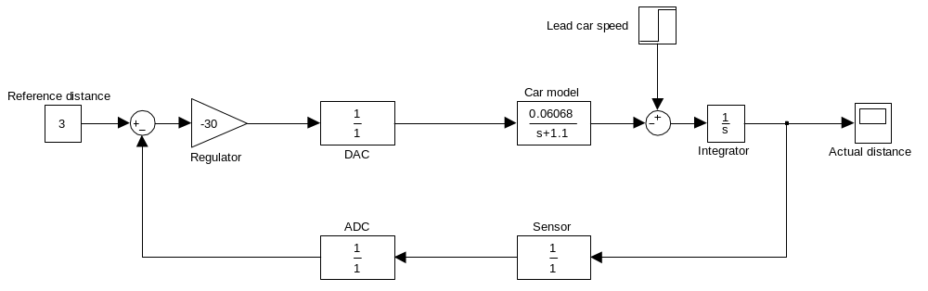
Figure 8, block diagram of a P-regulator
This can be realised with many different regulators, but keeping to the three main-stream regulators; P, PI and PID, we can see that we cannot use a P-regulator, as it is a type 0 system (it has a steady-state error != 0). We will however, for experiments sake, show how it could be used to implement the regulator, even if it will not be able to meet the stead-state error. Figure 8 shows a block diagram of a P-regulator.

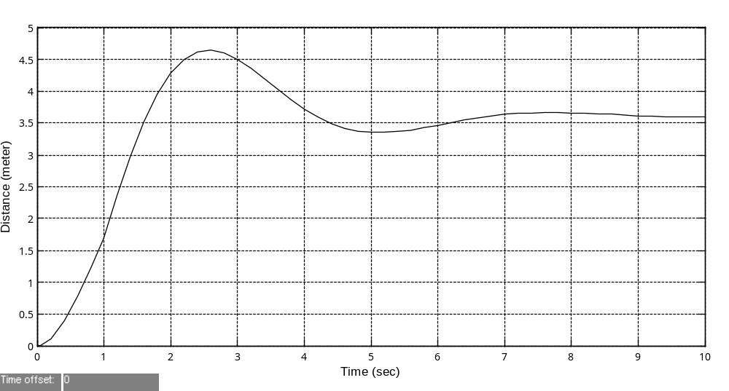
Figure 9, step response for pure gain regulator
Many different gain parameters were attempted. The first thing we notice is that a negative gain is required for the system to be stable. This is due to the system itself: "If we are too far away we must try and reduce the distance". We then attempted to change the value of the gain, and the higher the gain the faster the system reached its steady-state, and the close it was to the correct value, but the higher overshot it had. At Gain = -1 it took about 80 seconds to reach steady-state and with no overshot, but a final value of approx. 22, or a steady-state error of 22 - 3 = 19 meter or 533%. At a gain of -10 it took only about 10 seconds to reach steady-state and we have an overshot of about 7%, and a steady-state error of 1.75. Since we allowed 30% overshot, we can have a gain of approximately -30, which gives us an overshot of 30% and a settling time of about 7 seconds with a steady state error of 0.6. This is shown in Figure 9Error: Reference source not found above.

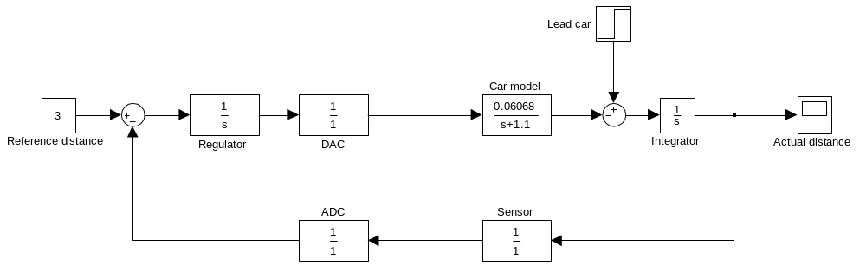
Figure 10, integrator replace the pure gain regulator

In order to get a type 1 regulator we need an integrator in the regulator. This is represented as 1/s in Laplace, and unfortunately has the consequence that the phase-response is moved down 90 degrees, reeking havoc on our phase margin. To counter-act this effect we can add a zero in the equation, as this will move the phase-response up 90 degrees. Naturally these 90 degrees up or down are not in the entire phase-band, but only for a certain interval. Here an important stability rule comes in; if the highest frequency where the gain is 1 is higher than -180 degrees the system is stable. Even if there are lower frequencies where the phase-margin is negative and the gain is > 1 - this may seem counter-intuitive, but it is true none the less.

In order to choose the coefficients of the regulator, under the constraints above, and with a fourth requirement

Requirement 4: As fast a rise time (i.e. response time) as possible

We have to follow the below steps:

- Realise that in order to have a steady-state error of zero we require to have a type 1 system, and that means having an integrator in the regulator. See Figure 9 of pure P-regulator for proof.
- Having a pure integrator in the system will lower the phase-margin to a level where it is not possible to achieve the min 45 degree phase margin.
- Adding a zero will lift the frequency response by 90 degrees in a "bubble", and as long as this "bubble" has the cross-over-frequency and it is above -135 degrees (required for 45 degrees phase-margin), then the system is stable.
- We can now choose the highest possible P that will ensure a max. 30% overshot and have the best possible rise-time. This means choosing the P as high as possible, i.e. exactly where the 30% is just met.

First we add the pure integrator in Figure 11.

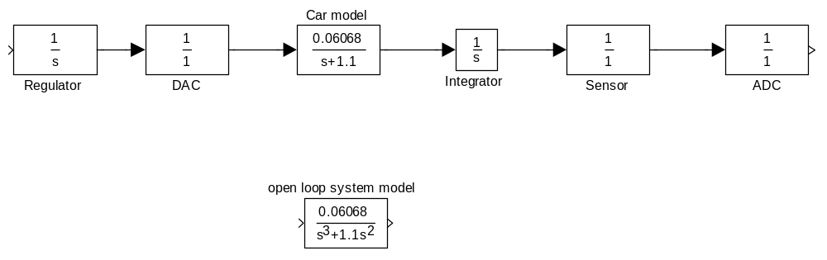
Figure 11, open-loop system of a PI regulator
Then we create a bode-plot of the open-loop system (simply multiple the transfer functions in the forward and feedback path). This gives the following plot in Figure 12.
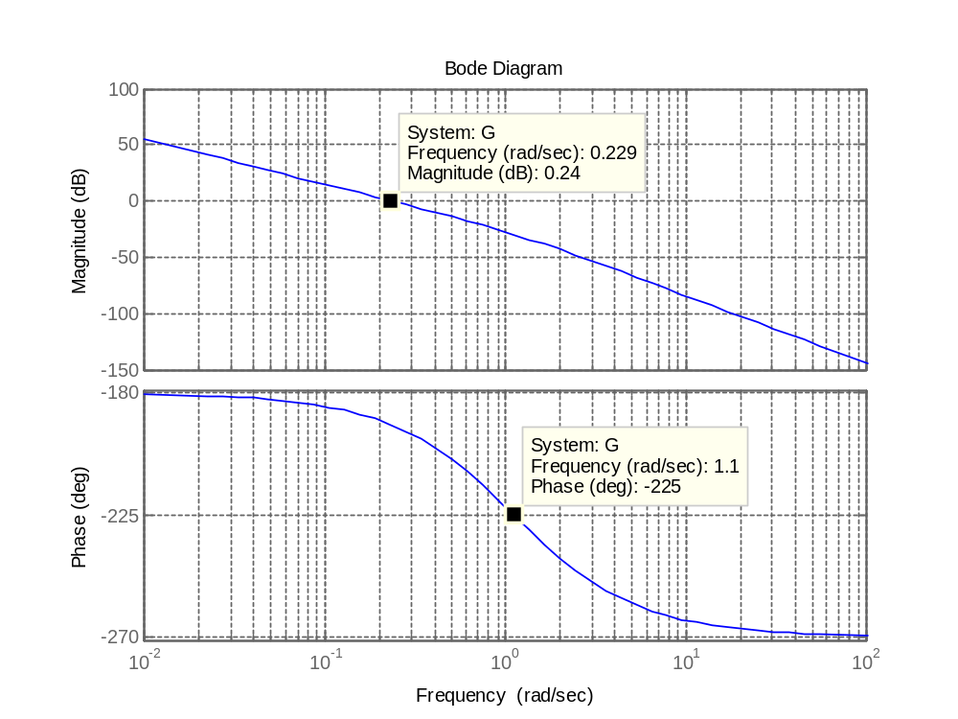
Figure 12, Bode plot of open loop system of a PI regulator
Here it may be seen that the open-loop system as a phase margin of -19, which is clearly unstable.

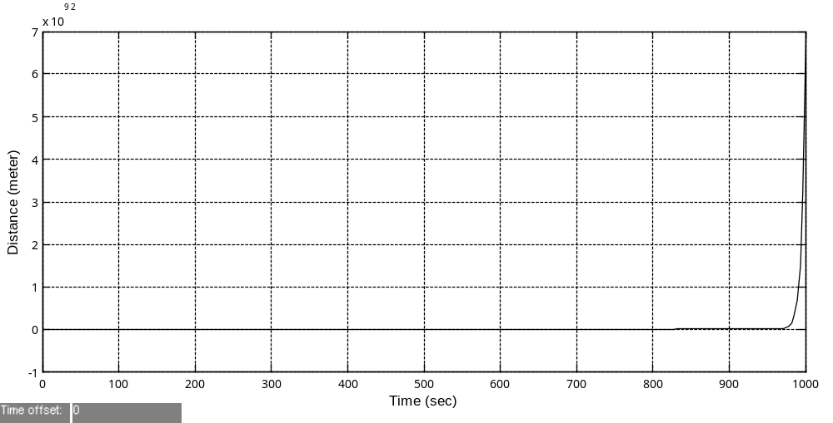
Figure 13, step response of PI-regulator
It also shows that increasing the phase margin by 90 degrees is sufficient to make the system stable. Increasing the phase can be achieved by adding a zero. We can also determine the lowest frequency where this zero may be placed, by determining the frequency at which a 90 degree increase in phase will give the desired 45 degree phase margin, or a phase of -135. This turns out to be at 1,1 rad/sec where the phase is -225, so our zero must be to the right of this point, but at the same time also greater than 0 (otherwise the system starts behaving funny), i.e. ]0;1,1].
This results in the following regulator:

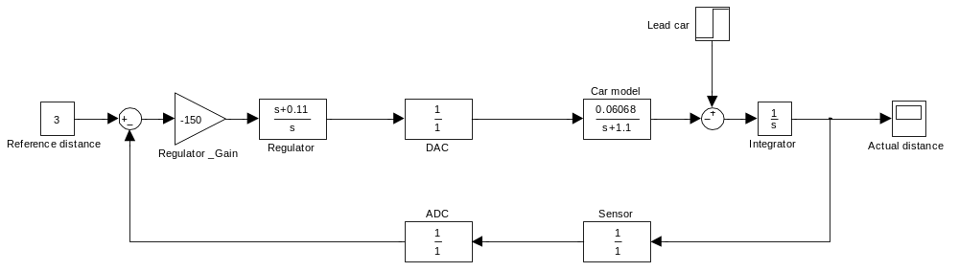
Figure 14, block diagram of a PI-regulator
Since we can control the gain we can naturally create a 45 degree phase margin anywhere in this interval. Secondly we can choose to look at the cross-over frequency, as we want this to be as high as possible. Unfortunately the cross-over frequencies for different values of the zero is almost identical, so for this reason we choose based on the gain. We want the zero that creates the highest gain, as this will help suppress noise in the system. Noise is suppressed by a factor of 1 + the open loop gain.

This gives us a zero in approximately 1.1 rad/s. We place this in the model and attempt to modify the gain to achieve an overshot of max. 30%. We realize that this is not possible, as we do not accelerate fast enough to keep up with the lead car's step speed (infinite acceleration), which is also unrealistic. We therefore only look at the second loop in the figure how much the distance swings under the curve. This gives us a gain of -150 (we remember from earlier that the gain has to be negative). The actual overshot will be smaller, as it is not possible for the lead car to accelerate as a step, only as a ramp:
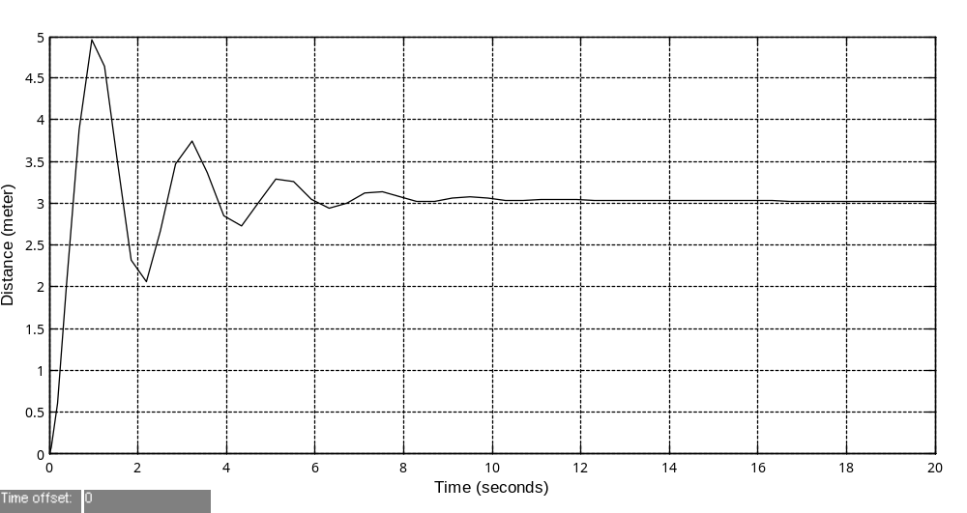
Figure 15, step response of PI-regulator
As it may be seen this does not have a very good ability to keep up when the other car changes speed. It will quickly fall far behind, or come dangerously close, to the other car, so even though it will eventually get to the right distance, it will feel strange to the driver. Let’s just say, he or she is sure to say: "I can follow better than this if I was driving myself".

The problem is that the system does not take the lead car's change in speed into account. If the lead car changes speed fast, we should accelerate fast to catch up, and if it only slowly changes speed, we should also only alter our speed slightly in order not to over-shoot too much.

